Learning Goals

After completing this activity, students should be able to:
- Identify the observational units in a lap-level racing dataset.
- Describe the shape, center, spread, and unusual observations in a distribution using a histogram.
- Use summary statistics and the 1.5 × IQR rule to identify potential outliers in a quantitative variable.
- Explain how adding a time-order variable, such as lap number, can provide context that is not visible in a histogram.
- Use subject-matter context to interpret unusual observations in real data.

Formula 1 is the highest class of single-seater auto racing. In each Grand Prix, drivers complete a fixed number of laps around a circuit, with the goal of finishing the full race distance in the shortest total time. Although a driver’s lap times are usually similar from lap to lap, they are not identical. Lap times can be affected by fuel load, tire wear, traffic, overtaking, pit stops, and changes in race conditions.
In this activity, we will analyze lap-time data for Max Verstappen in the 2023 Miami Grand Prix (located in the file Verstappen.csv). Verstappen started the race in ninth position but won the race after moving through the field. The race was unusually clean: all 20 cars that started were classified as finishers, and there were no major interruptions such as safety cars or red flags. This makes the race useful for studying lap times because a common source of slow lap, crashes or race stoppages, did not occur.
One important feature of Verstappen’s race strategy was his pit stop. Most drivers in this race made only one pit stop, and Verstappen’s stop occurred late in the race to change tires. A pit stop can create an unusually slow lap because the driver must slow down to enter pit lane, follow the pit-lane speed limit, stop for the tire change, and then accelerate back onto the track. Depending on where the pit lane crosses the start/finish line, this time loss may appear on the lap when the driver enters pit lane, the following lap, or both. Other unusual laps may occur near the beginning of the race, when cars are closer together and drivers are fighting for position.

Part 1: Univariate Analysis of Lap Times

- Identify (in words) the observations (cases) of the data set for the 2023 F1 Miami Grand Prix

- Use the histogram to describe shape, center, and spread of Max Verstappen’s Lap Times (in seconds) during the race. Also indicate any unusual observations you notice.

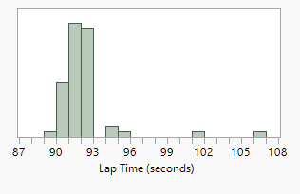

- Use the following summary statistics of Verstappen’s lap times to answer the question below.

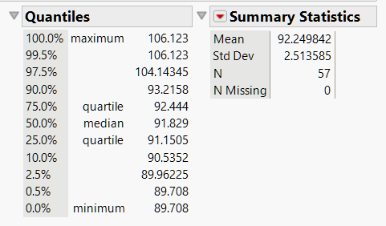

According to the 1.5 × IQR rule, which lap time(s) would be considered outliers? Does this match what you visually noticed in the histogram?

- Based on the description of an F1 race above, what is one possible race-related explanation for one of the high outliers identified using the 1.5 × IQR rule?

Part 2: Incorporating Lap Number into Analysis

- The graph below plots Max Verstappen’s lap time against lap number for the 2023 Miami Grand Prix. Describe the overall pattern in his lap times over the course of the race. Be sure to comment on any unusual laps.

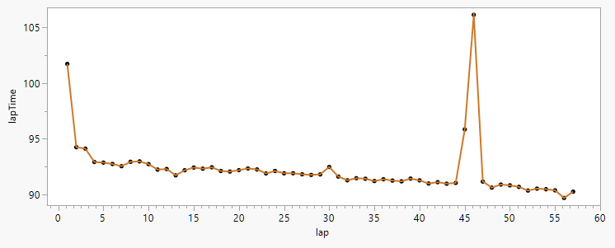

- Earlier, the 1.5 × IQR rule identified several unusually large lap times. Where do those unusually large lap times occur in the race?

- Below is a map of the 2023 Miami Grand Prix race track. The pit lane is the narrow road between turn 18, near the end of a lap, and turn 2, shortly after the beginning of the next lap. Red arrow represents the direction of traffic. Typically, the actual tire change during a pit stop takes only about 3 seconds. However, the total time lost during a pit stop is much larger because drivers must slow down to the pit-lane speed limit, which is 80 km/h, compared with an average racing speed of about 200 km/h on the regular part of the track.

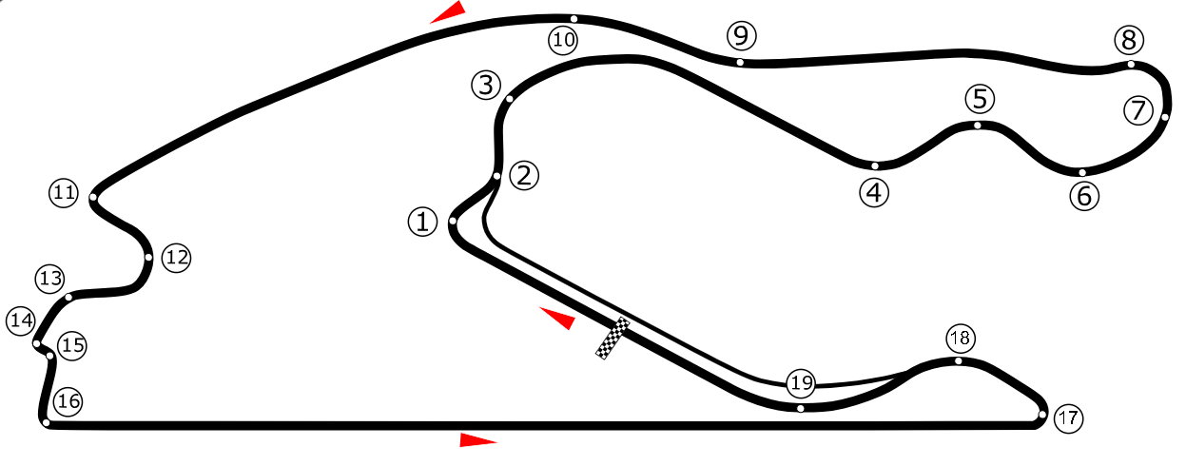
Source: By GabrielStella - Own work, CC BY-SA 3.0, https://commons.wikimedia.org/w/index.php?curid=103863916

Verstappen’s lap 46 was his slowest lap of the race. Why does the location of the pit lane help explain why this lap time was so large?

- In this activity, you analyzed Verstappen’s lap times using both a histogram and a plot of lap time versus lap number. What did each graph help you see, and why was the lap-number plot especially useful for interpreting the outliers?

